# Second Year B. Tech (EL&CE)

**Semester: IV Subject:** Basic IoT Lab

**Name: Shreerang Mhatre Class: Sy**

**Roll No: 29 Batch: A2**

# Experiment No: 08

**Name of the Experiment: To introduce new hardware platforms TinyML**

**Performed on: 19/04/23**

**Teacher’s Signature with date**

|  |
| --- |
| **Marks** |
|  |
|  |

**Submitted on: 28/04/23**

# Aim: To introduce hardware platforms for IoT based design TinyML

**Pre-requisite:** Knowledge of Electronics and circuits, Knowledge of Assembly and C Programming language.

# Objective:

1. To introduce new hardware platforms for IoT based design.
2. To understand different features of new hardware platforms.

# Components and equipment required:

Arduino Uno Board, TinyML

# Theory:

IoT hardware platforms are considered as the most significant component of the IoT environment. One IoT device can be connected to other IoT device to enable the information exchange using suitable Internet protocols. IoT platforms works as a bridge between the device sensors and data networks. It gives data connectivity to the sensor system and helps to understand using back-end applications and helps to analyse the huge data generated by sensors.

# What is TinyML

TinyML is a field of study in Machine Learning and Embedded Systems that explores the types of models you can run on small, low-powered devices like microcontrollers. It enables low- latency, low power and low bandwidth model inference at edge devices. While a standard consumer CPUs consume between 65 watts and 85 watts and standard consumer GPU consumes anywhere between 200 watts to 500 watts, a typical microcontroller consumes power in the order of milliwatts or microwatts. That is around a thousand times less power consumption. This low power consumption enables the TinyML devices to run unplugged on batteries for weeks, months, and in some cases, even years, while running ML applications on edge.

# Advantages of TinyML

1. **Low Latency:** Since the model runs on the edge, the data doesn't have to be sent to a server to run inference. This reduces the latency of the output.
2. **Low Power Consumption:** As we discussed before, microcontrollers consume very little power. This enables them to run without being charged for a really long time.
3. **Low Bandwidth:** As the data doesn’t have to be sent to the server constantly, less internet bandwidth is used.
4. **Privacy:** Since the model is running on the edge, your data is not stored in any servers.

.

# Applications of TinyML

By summarizing and analyzing data at the edge on low power devices, TinyML offers many unique solutions. Even though TinyML is an emerging field, it has been used in production for years. The “OK Google”, “Alexa”, “Hey Siri” wake words are an example of TinyML. Here, the devices are always on and are analyzing your voice to detect the wake word. I’ll add some more applications of TinyML here.

1. **Industrial Predictive Maintenance:** Machines are prone to fault. Using TinyML on low powered devices, it is possible to monitor the machine and predict faults ahead of time constantly. This predictive maintenance can lead to significant cost savings. Ping Services, an Australian startup, has introduced an IoT device that autonomously monitors wind turbines by magnetically attaching to the outside of the turbine and analyzing detailed data at the edge. This device can alert the authorities regarding potential issues even before it occurs.
2. **Healthcare:** The Solar Scare Mosquito project uses TinyML to curb the spread of mosquito-borne diseases like Dengue, Malaria, Zika Virus, Chikungunya, etc. It works by detecting the mosquito breeding conditions and agitates the water to prevent mosquito breeding. It runs on solar power and can thus run indefinitely.
3. **Agriculture:** The Nuru app helps farmers detect diseases in plants just by taking a picture of it by running Machine Learning models on the device using TensorFlow Lite. Since it works on the device, there is no need for an internet connection. This is a crucial requirement for remote farmers since they might not have proper internet connection in their place.
4. **Ocean Life Conservation:** Smart ML-powered devices are used to monitor whales in real- time in waterways around Seattle and Vancouver to avoid whale strikes in busy shipping lanes.

# Description :

1. **Hardware:** The **Arduino Nano 33 BLE Sense** is the suggested hardware for deploying Machine Learning models on edge. It contains a 32-bit ARM Cortex-M4F microcontroller running at 64MHz with 1MB of program memory and 256KB RAM. This microcontroller provides enough horsepower to run TinyML models. The Arduino Nano 33 BLE Sense also contains colour, brightness, proximity, gesture, motion, vibration, orientation, temperature, humidity, and pressure sensors. It also contains a digital microphone and a Bluetooth low energy(BLE) module. This sensor suite will be more than enough for most applications.
2. **Machine Learning Framework:** There are only a handful of frameworks that cater to TinyML needs. Of that, **TensorFlow Lite** is the most popular and has the most community support. Using TensorFlow Lite Micro, we can deploy models on microcontrollers.
3. **Learning Resources:** Since TinyML is an emerging field, there aren’t many learning materials as of today. But there are a few excellent materials like Pete Warden and Daniel Situnayake’s book, “TinyML: Machine Learning with TensorFlow Lite on Arduino and Ultra-Low-Power”, [Harvard University’s Course on TinyML by Vijay Janapa Reddi](https://www.edx.org/professional-certificate/harvardx-tiny-machine-learning),

and [Digikey’s blogs and videos on TinyML](https://www.digikey.in/en/maker/projects/intro-to-tinyml-part-1-training-a-model-for-arduino-in-tensorflow/8f1fc8c0b83d417ab521c48864d2a8ec).

# Diagram of TinyML:

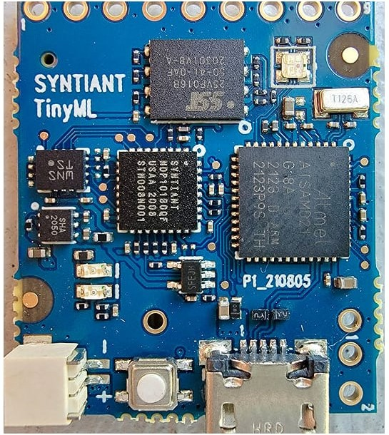

**Key Features**

* Neural Decision Processor: NDP101
* Host processor: SAMD21 Cortex-M0+ 32bit low power ARM MCU, including:
* 256KB flash memory
* 32KB host processor SRAM
* Board power supply: 5V micro-USB or 3.7V LiPo battery
* 5 Digital I/Os compatible with Arduino MKR series boards
* 1 UART interface (included in the digital I/O Pins
* 1 I2C interface (included in the digital I/O Pins)
* 2MB on-board serial flash
* 48MHz system clock
* One user defined RGB LED
* uSD card slot (uSD card not included)
* BMI160 6 axis motion sensor
* SPH0641LM4H microphone Program CODE :

Output :

Conclusion :

Post lab questions :

1. Describe different features present in the TinyML kit .

